1. **Introduction**

* **Project Title: Store Manager: Keep Track of Inventory**
* **Team ID: NM2025TMID47614**
* **Team Leader: MONIKA K &** [**monimoni0019@gmail.com**](mailto:monimoni0019@gmail.com)
* **Team Members:**

**– THIRISHA L &** [**thirisha253@gmail.com**](mailto:thirisha253@gmail.com)

**– PARAMESWARI S &** [**parames2616@gmail.com**](mailto:parames2616@gmail.com)

**– GOPALAKRISHNAN M &** [**gopalmp2007@gmail.com**](mailto:gopalmp2007@gmail.com)

1. **Project Overview**

* **Purpose: To provide an efficient inventory management system that ensures real-time stock updates, smooth sales checkout, and timely alerts for low inventory.**
* **Features:**

**– Real-time Stock Updates**

**– Cart & Checkout Management**

**– Low Stock Alerts**

**– Product Management**

1. **Architecture**

* **Frontend: React.js with Bootstrap and Material UI**
* **Backend: Node.js and Express.js managing server logic and API endpoints**
* **Database: MongoDB stores user data, project information, applications, and chat messages**

1. **Setup Instructions**

* **Prerequisites:**

**– Node.js**

**– MongoDB**

**– Git**

**– React.js**

**– Express.js**

**– Mongoose**

**– Visual Studio Code**

1. **Folder Structure**

**inventory-management-frontend/**

**├ node_modules/**

**├ public/**

**├ src/**

**├ components/**

**├ Cart/**

**├ Inventory/**

**├ Product/**

**├ Sales/**

**├ context/**

**├ pages/**

**├ hooks/**

1. **Running the Application**

* **Frontend:**

**cd client**

**npm start**

* **Backend:**

**cd server npm**

**start**

* **Access: Visit htp://localhost:3000**

1. **API Documentation**

* **User:**

**– /api/user/register**

**– /api/user/login**

* **Projects:**

**– /api/projects/create**

**– /api/projects/:id**

* **Applications:**

**– /api/apply**

* **Chats:**

**– /api/chat/send**

**– /api/chat/:userId**

1. **Authentication**

* **JWT-based authentication for secure login**
* **Middleware protects private routes**

1. **User Interface**

* **Landing Page**
* **Freelancer Dashboard**
* **Admin Panel**
* **Project Details Page**

1. **Testing**

* **Manual testing during milestones**
* **Tools: Postman, Chrome Dev Tools**

1. **Screenshots or Demo**

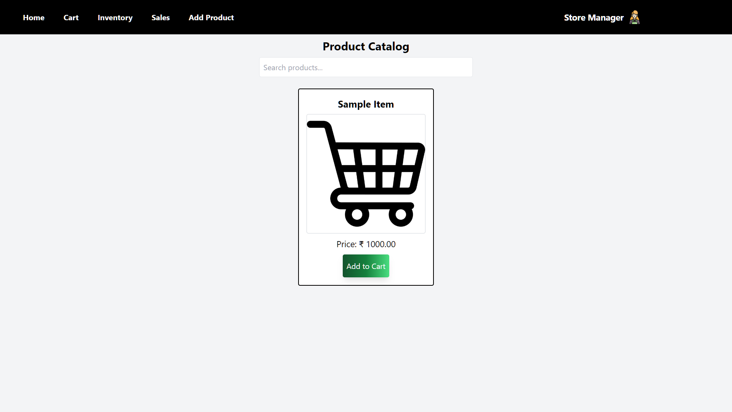

**Drive link of Demo Video:** [**https://drive.google.com/file/d/1qJiE8aWWkeZkiklFTP8VZtuc-y-8-1NS/view?usp=sharing**](https://drive.google.com/file/d/1qJiE8aWWkeZkiklFTP8VZtuc-y-8-1NS/view?usp=sharing)

1. **Known Issues: No Issues.**
2. **Future Enhancements: In feature we can upgrade the page for our need.**